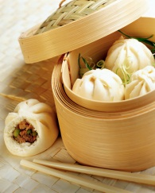
Chinese Club Event: How to Make Dumplings

Directions: Work in groups. Everyone needs to finish this handout.
What are the ingredients in a Chinese Dumpling? List 5 or more
1.
2.
3.
4.
5.

How do you make a Chinese dumpling? List 5 steps. You can take pictures of each step to help you remember.
First, _____________________________________________________________________________
Next, _____________________________________________________________________________
After that, _________________________________________________________________________
Then, _____________________________________________________________________________
Finally,____________________________________________________________________________

Take at least one picture.

Due Friday, Nov. 16 (tomorrow)

Journal #2

Type a one-page, double spaced journal. State your opinion and support. Include words 60-level words from Top Notch—at least 5-8 words.

Topic:
- Tell us the story of our class activity today. Include your opinion of the event at the beginning of the journal.

- Would you recommend Chinese dumplings or not? Explain with all three levels of information: 1. your opinion
2. supporting points
3. details
Due Friday, Nov. 16 (tomorrow)

